|  |  |
| --- | --- |
| Status | In Progress |
| Comments |  |

USER Page

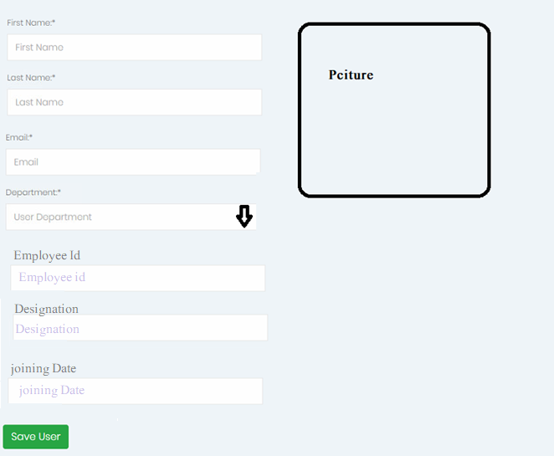

There are 3 users types in whole application.

1. Admin
2. Attendant
3. User

Admin user will be available as default for each Company

there are only one admin and one attendant in one company. And we may have multiple users.

Admin & Attendant can be merged but not recommended to keep controls high and strict.

* Only Admin can create user.
* One user can be in one department only
* There will be no form for adding department. Admin have to choose it from down list. If it does not exit he will add it from here.
* Log must be maintained.